EXPERIMENT 1A

Matplot Library – Data Visualization

Aim:

To analyze the trend of data science job postings over the last decade.

Algorithm:

1. Import pandas, matplotlib, and seaborn libraries.

2. Create a dataset with Year and Job_Postings values.

3. Convert the dataset into a pandas DataFrame.

4. Set Seaborn style to 'whitegrid'.

5. Create a line plot with Year on the x-axis and Job_Postings on the y-axis.

6. Add markers and set the line color to black.

7. Add title and axis labels.

8. Display the plot.

Program:

import pandas as pd

import matplotlib.pyplot as plt

import seaborn as sns

data = {

'Year': list(range(2014, 2025)),

'Job_Postings': [1500, 1800, 2300, 3100, 4200, 5000, 6200, 7200, 8500, 9700, 11000]

}

df = pd.DataFrame(data)

print(df.head())

sns.set(style='whitegrid')

plt.figure(figsize=(10, 6))

sns.lineplot(x='Year', y='Job_Postings', data=df, marker='o', color='black')

plt.title('Trend of Data Science Job Postings (2014–2024)', fontsize=16)

plt.xlabel('Year', fontsize=12)

plt.ylabel('Number of Job Postings', fontsize=12)

plt.tight_layout()

plt.show()

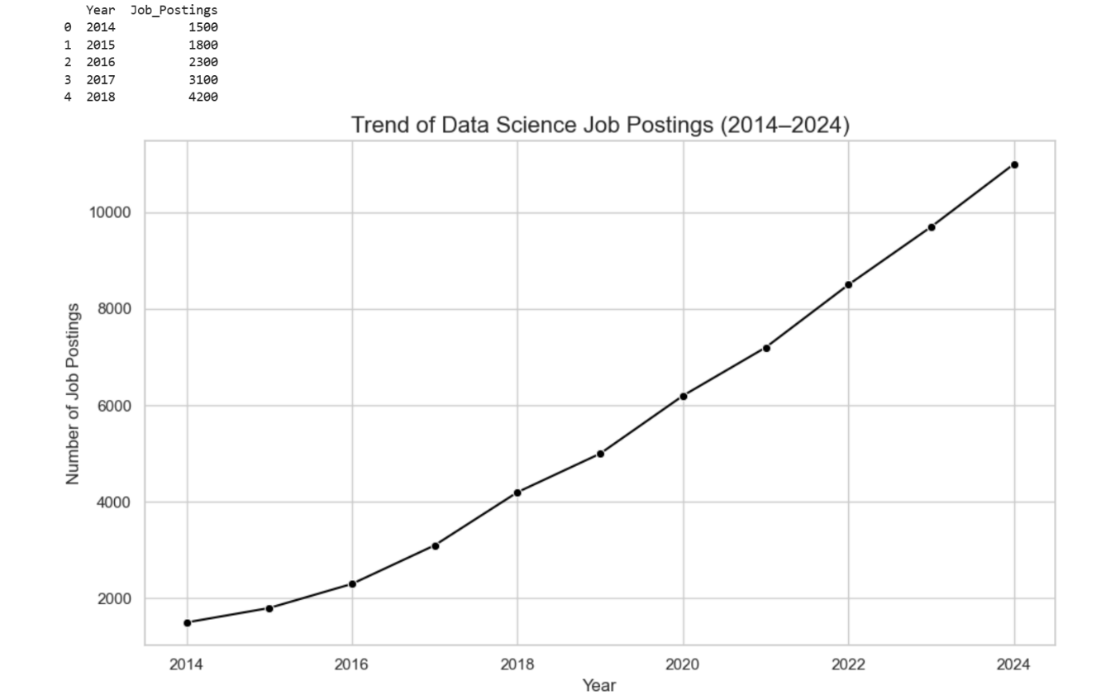Output:

Result:

Hence a program to analyze the trend of job postings over a decade is written and executed successfully and line graph is plotted.